Catalase Enzyme Reaction Student Experiment - Eden Tomes

# Rationale:

Cells, the fundamental units of life, depend on a multitude of biochemical reactions for survival and function, collectively known as metabolism (*Biology LibreTexts*, 2016). Many of these essential reactions would occur too slowly to sustain life without biological catalysts called enzymes (*Cooper*, 2000). Enzymes, primarily proteins, accelerate reaction rates by lowering the activation energy. They achieve this by binding to specific reactant molecules, or substrates, at a region called the active site, facilitating their conversion into products (*Robinson*, 2015).

Catalase is a crucial enzyme found in nearly all aerobic organisms, playing a vital protective role. It catalyses the decomposition of hydrogen peroxide (H₂O₂), a toxic byproduct of cellular metabolism, into harmless water (H₂O) and oxygen (O₂) (*Zamocky et al.*, 2008). This detoxification prevents oxidative damage to cellular components, a key aspect of how cells maintain homeostasis (*Nandi*, 2019).

The rate of enzyme-catalysed reactions is influenced by factors such as temperature, pH, substrate concentration, and enzyme concentration (*Robinson*, 2015). While a previous experiment explored temperature effects, this investigation focuses on how varying enzyme concentration impacts reaction rates. According to established enzyme kinetics, when substrate is abundant, the initial reaction rate is directly proportional to the enzyme concentration (*Aebi*, 1984). This is because more enzyme molecules mean more active sites are available to process the substrate, leading to faster product formation (*Robinson*, 2015).

This experiment aims to systematically investigate how altering the volume of catalase solution, thereby changing its effective concentration, affects the initial rate of oxygen production from hydrogen peroxide decomposition. By keeping substrate concentration, volume, and temperature constant, the study will isolate the influence of enzyme quantity on reaction rate. This will provide insight into how cells can regulate metabolic pathways by controlling enzyme availability.

# Research Question:

How does increasing the volume of catalase solution (representing different enzyme concentrations) affect the rate of oxygen gas production when reacting with a constant volume and concentration of hydrogen peroxide?

# Methodology:

## Original Experiment

The original experiment (provided through *Seymour*, 2019) investigated enzyme activity by reacting 1mL of stock catalase solution (yeast) with a set volume of hydrogen peroxide (10mL) in a reaction chamber. The chamber is submerged in a room-temperature water bath. Oxygen gas, the product of the reaction, is collected over water in an inverted measuring cylinder, and its volume is recorded at regular time intervals (every 30 seconds for 5 minutes) to determine the rate of reaction.

## Modifications

The original experimental design was refined and redirected to specifically investigate the effect of enzyme concentration on reaction rate. To improve data reliability, the procedure was modified to include three independent trials for each condition. This replication minimizes the impact of random error and allows for statistical analysis through the calculation of means and standard deviations. The experiment was redirected from using a single enzyme volume to systematically testing three different volumes of catalase solution (1mL, 2mL, and 4mL). Since the stock solution's concentration was constant, altering its volume served as a direct method for varying the effective enzyme concentration in the reaction mixture.

## Safety & Ethical Considerations

|  |  |  |
| --- | --- | --- |
| **Hazard** | **Identified Risk(s)** | **Control Measure(s)** |
| Hydrogen Peroxide (H202) | * Skin irritation or mild chemical burns. * Eye irritation or damage. | * Wear safety goggles and a lab coat at all times. * Handle H2O2 with care to avoid spills. * If H2O2 contacts skin, rinse immediately with plenty of water |
| Glassware (test tubes, beakers) | * Cuts from breakage. | * Handle carefully and avoid excessive force. * Keep glassware away from the edge of the bench. * Dispose of any broken glassware in a designated broken glass bin. |
| Chemical Spills | * Slip hazard on the floor. * Contamination of the work area or equipment. | * Clean up any spills immediately with paper towels as per teacher instructions. * Work on a clear, uncluttered bench space. |

# Processed Data + Calculations:

Table 1: Sample Calculations

|  |  |
| --- | --- |
| **Calculation** | **Example** |
| **Mean oxygen volume** |  |
| **Standard deviation (SD) for a sample population** | Calculated in excel by using STDEV.S and the three trial measurements for each catalase volume. For 1mL: |
| **Standard error** | Calculated by dividing the standard deviation by the square root of the sample size. For 1mL: |
| **Upper/lower limit** | Calculated as follows: |
| **P-value** | P-values were calculated in excel using the T.DIST function and the trial differences between each pair of conditions. |

Table 2: Processed data table for volume of Oxygen After 300 Seconds  
(values are in mL and rounded to 2 decimal places)

|  |  |  |  |
| --- | --- | --- | --- |
|  | **1mL Catalase** | **2mL Catalase** | **4mL Catalase** |
| **Trial 1** | 4.00 | 0.70 | 11.00 |
| **Trial 2** | 3.00 | 5.00 | 8.50 |
| **Trial 3** | 0.70 | 5.00 | 4.50 |
| **Mean** | 2.57 | 3.57 | 8.00 |
| **Std. Deviation** | 1.69 | 2.48 | 3.28 |
| **Std. Error** | 0.98 | 1.43 | 1.89 |
| **Upper Limit** | 5.95 | 8.53 | 14.56 |
| **Lower Limit** | 0.00 | 0.00 | 1.44 |
| **P-Value** |  | Vs 1mL: 0.35 | Vs 2mL: 0.15 Vs 1mL: 0.01 |

## Interpretation:

After 300 seconds, mean oxygen production increased with enzyme concentration: 2.57 mL (1mL), 3.57 mL (2mL), and 8.00 mL (4mL). This trend was statistically significant when comparing the lowest and highest concentrations (1mL vs 4mL, p=0.01). However, the differences between adjacent steps were not significant (1mL vs 2mL, p=0.35; 2mL vs 4mL, p=0.15), assuming a significance level of α=0.05. The large standard errors (±1.43 mL and ±1.89 mL for the 2mL and 4mL treatments) likely masked the expected difference between these groups, indicating low precision.

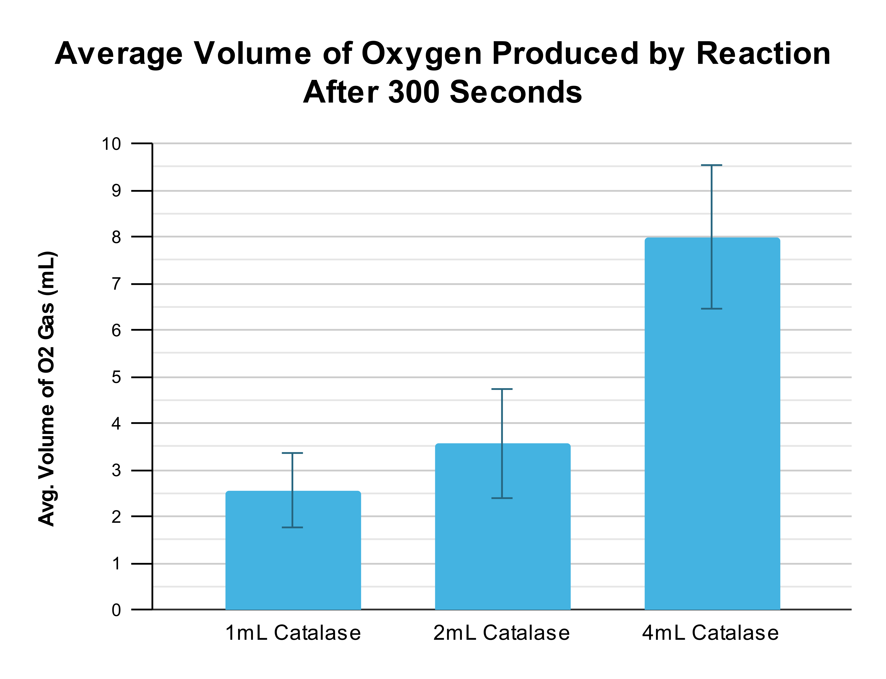  
Graph 1: Column Graph (standard deviations represented by error bars)

## Interpretation:

The column graph shows the mean volume of oxygen gas produced after 300 seconds for each catalase volume treatment. The 4mL catalase treatment produced the highest mean oxygen volume (8.00 mL), followed by 2mL catalase (3.57 mL), and 1mL catalase (2.57 mL). This demonstrates a general positive relationship between enzyme volume and oxygen production, with the 4mL treatment producing approximately 3.1 times more oxygen than the 1mL baseline and 2.2 times more than the 2mL treatment.

## Analysis:

The data indicates substantial variability within each treatment group, as evidenced by the large standard deviations represented by the error bars (1mL: ±1.69 mL, 2mL: ±2.48 mL, 4mL: ±3.28 mL). The overlapping error bars between the 1mL and 2mL treatments suggest these results may fall within the same range, indicating no statistically significant difference between these enzyme concentrations. However, the 4mL treatment shows minimal overlap with the other treatments, suggesting a potential significant difference. The increasing magnitude of standard deviations with higher enzyme concentrations indicates decreasing precision in measurements, possibly due to more vigorous reactions being harder to measure consistently or substrate limitation effects occurring at higher enzyme concentrations.

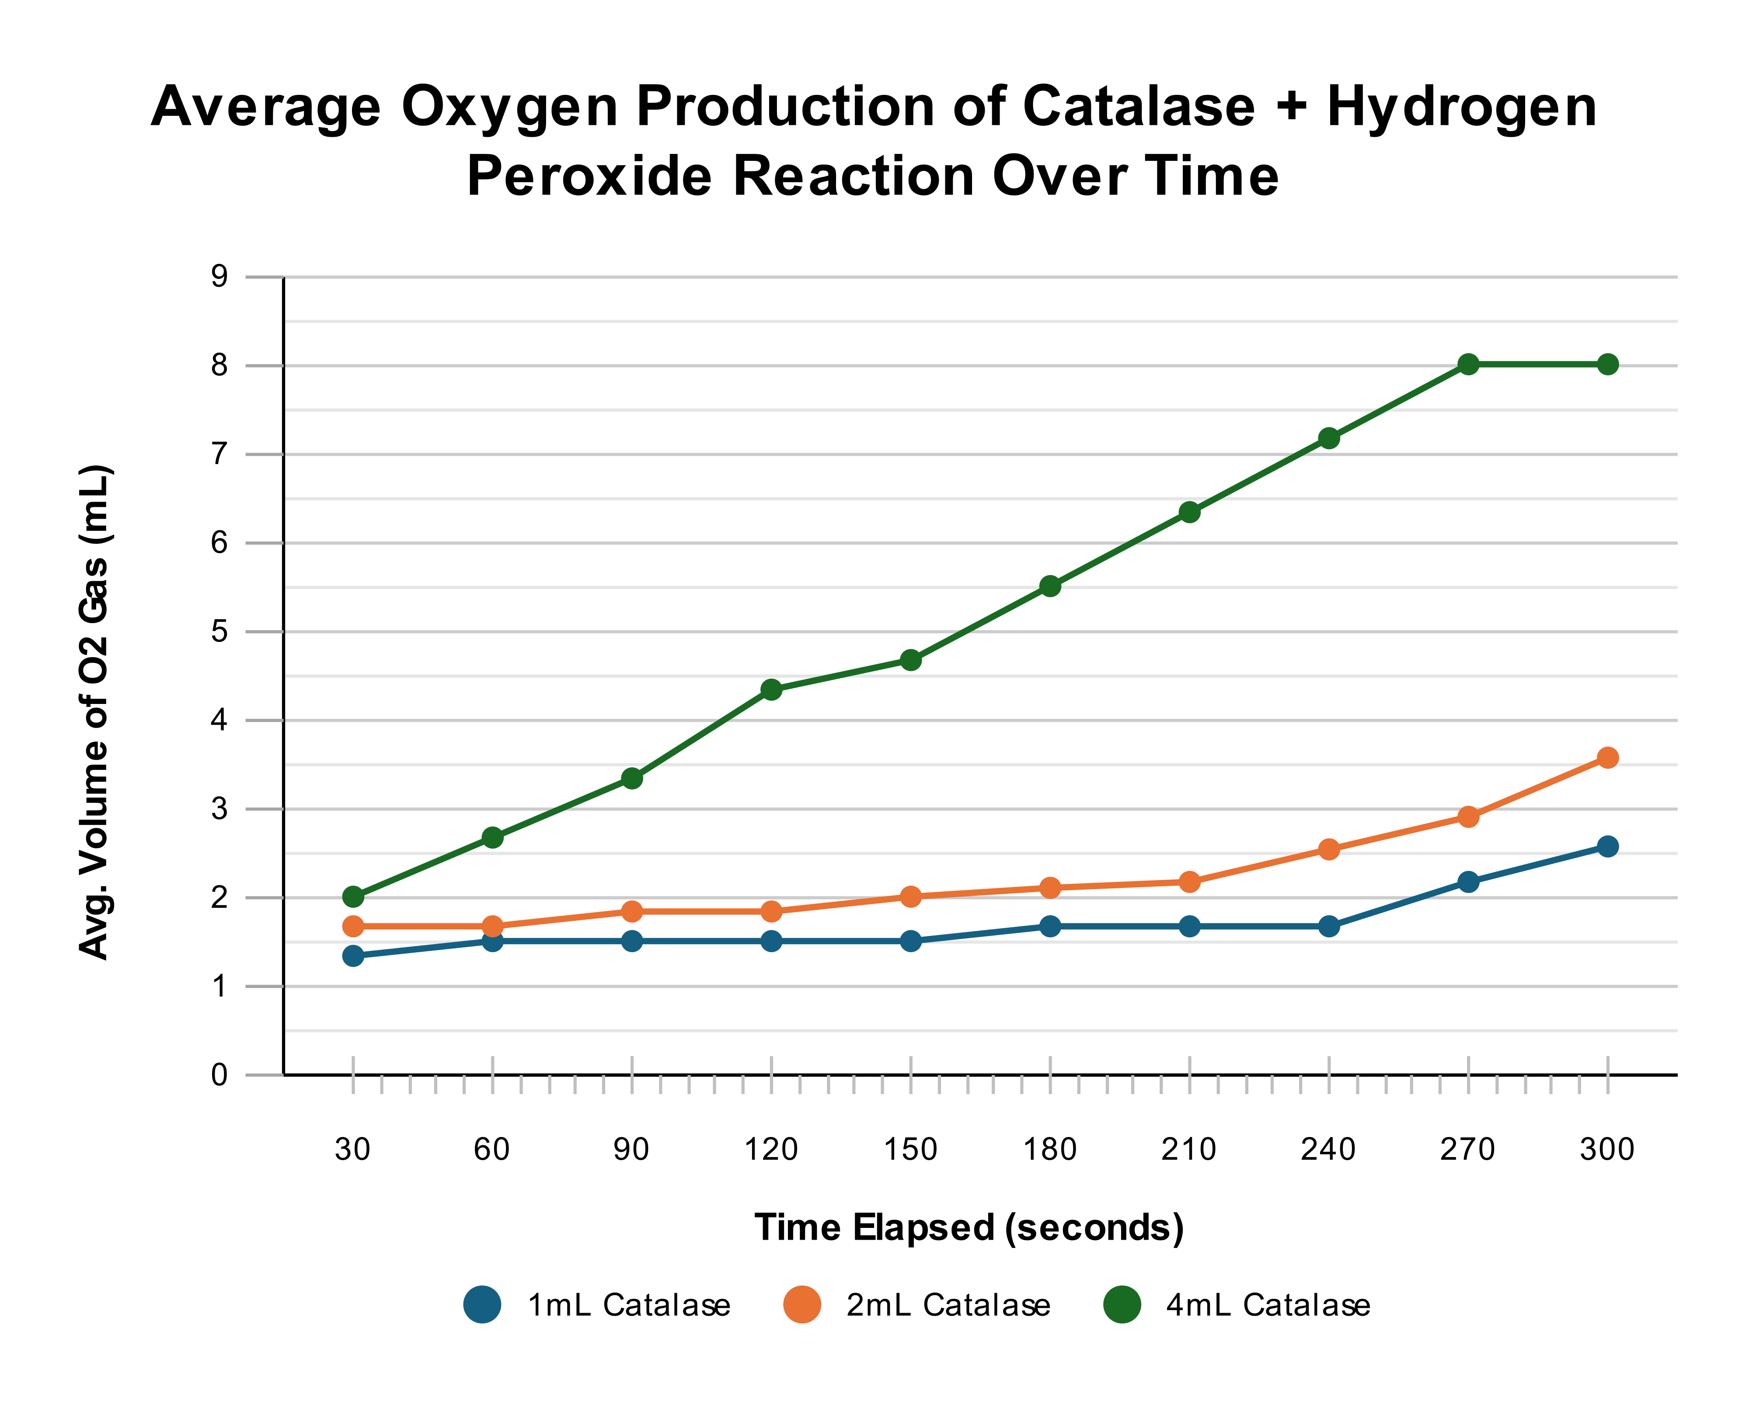  
Graph 2: Line Graph - Mean oxygen volume over a 300 second period

## Interpretation:

The line graph demonstrates the cumulative oxygen production over the 300-second experimental period for each catalase treatment. All treatments show the characteristic pattern of enzyme kinetics, with an initial rapid rate of oxygen production that gradually levels off as the reaction progresses. The 4mL catalase treatment exhibits the steepest initial slope and maintains the highest oxygen production throughout the time period, reaching approximately 8.00 mL by 300 seconds. The 2mL treatment shows a moderate rate of production, while the 1mL treatment displays the slowest rate, reaching only 2.57 mL after 300 seconds.

## Analysis:

The initial reaction rates (represented by the steepness of the early slopes) follow the expected pattern where higher enzyme concentrations produce faster initial rates of oxygen evolution. This aligns with enzyme kinetics theory, where increased enzyme concentration provides more active sites for substrate binding when substrate is in excess. However, the leveling off observed in all treatments suggests that substrate depletion may be occurring before the 300-second endpoint. The plateau is most evident in the 4mL treatment, indicating that the 10mL of hydrogen peroxide substrate becomes limiting when enzyme concentration is high, preventing the reaction from maintaining its initial rate throughout the entire observation period. This plateau effect compromises the ability to accurately assess the true relationship between enzyme concentration and reaction rate, as the measured values at 300 seconds may not reflect the initial rate conditions where enzyme kinetics principles are most applicable.

# Evaluation:

## Limitations Of Evidence

The experiment's low reliability is evidenced by high standard deviations (±1.69 to ±3.28 mL). This variability severely limited the experiment's statistical power, as illustrated by the p-values. For instance, despite the mean oxygen production for the 4mL treatment being more than double that of the 2mL treatment (8.00 mL vs 3.57 mL), the difference was not statistically significant (p=0.15). This demonstrates that extreme variance and a small sample size (n=3) masked a large, real effect, limiting the validity of conclusions drawn from intermediate comparisons.

# Sources Of Error:

## Affecting Reliability

* The gas collection apparatus lacks precision in measuring oxygen volume. The water displacement method and visual reading of gas volume contributes to imprecision in the data (±0.5 mL reading uncertainty). However, the variation in the data is greater than this measurement uncertainty; therefore, there must be other sources of imprecision.
* The samples were not standardized for reaction initiation timing. Random variation exists in the sealing and submersion process of the reaction chamber. This could explain some of the remaining imprecision in the data, as inconsistent reaction start times would lead to variable gas loss.
* The catalase solution homogeneity was not verified prior to conducting the experiment. Therefore, it is not known whether each aliquot contained identical enzyme concentrations, leading to random biological variation affecting the reaction rates.

## Affecting Validity

* The water displacement method leads to underestimation of actual gas volume due to oxygen dissolution. Therefore, the volume of oxygen produced is systematically underestimated. In addition, the oxygen volume is determined indirectly which could lead to greater variability in the data.
* The experimental design does not maintain constant substrate concentration across treatments. The varying total reaction volumes (11mL, 12mL, 14mL) dilute the hydrogen peroxide to different concentrations, introducing a confounding variable that affects the validity of isolating enzyme concentration effects.
* The gas collection method does not account for substrate depletion at higher enzyme concentrations. The 300-second endpoint measurement does not represent true initial rates, as substrate limitation occurs before completion, particularly in the 4mL treatment. Therefore, this could contribute to the data being inaccurate for determining the enzyme concentration-rate relationship.

# Suggested Improvements & Extensions:

## Suggested Improvements:

Reducing the random error inherent in the experimental process would increase reliability. In this experiment, the reliability of the data could be improved by increasing the replication for each condition (minimum 5+ trials) and standardizing the reaction initiation procedure.

To address the imprecision in gas measurement, a gas syringe should be used instead of water displacement, which would eliminate oxygen dissolution effects and provide direct, more accurate volume readings. This would improve both the reliability of data and validity of the experimental process.

Maintaining constant total reaction volume across all treatments by adding distilled water to equalize volumes would ensure identical substrate concentrations, allowing the results to isolate the effect of enzyme concentration. In addition, ensuring homogeneity of the catalase stock solution through thorough mixing before each aliquot would reduce biological variation.

## Suggested Extensions:

* Redirect the experiment by investigating a wider range of enzyme concentrations with smaller incremental increases to better define the enzyme concentration-rate relationship and identify saturation points.
* Extend the experiment by investigating the effect of substrate concentration while keeping enzyme concentration constant, providing a comprehensive exploration of enzyme kinetics.

# Conclusion:

In conclusion, the evidence suggests that increasing the volume of catalase solution does cause a measurable increase in the rate of oxygen gas production, with a statistically significant difference found between the 1mL and 4mL treatments (p=0.01). However, the lack of significance in other comparisons (e.g., 2mL vs 4mL, p=0.15), despite large differences in mean production, highlights that the experiment's conclusion is limited by low precision. Therefore, while the overall trend is supported, the data's high variability prevents the establishment of a definitive quantitative relationship and confirmation of the theoretical proportionality between enzyme concentration and initial reaction rate.

**Word Count: 1964**

# Reference List:

1. Aebi, H. (1984). Catalase in vitro. *Methods in Enzymology*, [online] 105, pp.121–126. doi:[https://doi.org/10.1016/s0076-6879(84)05016-3.](https://doi.org/10.1016/s0076-6879(84)05016-3)
2. Biology LibreTexts. (2016). *1.16: Types of Biochemical Reactions*. [online] Available at: [https://bio.libretexts.org/Bookshelves/Introductory_and_General_Biology/Introductory_Biology_(CK-12)/01%3A_Introduction_to_Biology/1.16%3A_Types_of_Biochemical_Reactions.](https://bio.libretexts.org/Bookshelves/Introductory_and_General_Biology/Introductory_Biology_(CK-12)/01%3A_Introduction_to_Biology/1.16%3A_Types_of_Biochemical_Reactions)
3. Cooper, G. (2000). *The Central Role of Enzymes as Biological Catalysts*. [online] National Library of Medicine. Available at: <https://www.ncbi.nlm.nih.gov/books/NBK9921/>.
4. Nandi, A. (2019). Role of Catalase in Oxidative Stress- and Age-Associated Degenerative Diseases. *Oxidative Medicine and Cellular Longevity*, [online] 2019(9613090). doi:<https://doi.org/10.1155/2019/9613090>.
5. Robinson, P. (2015). Enzymes: Principles and Biotechnological Applications. *Essays in Biochemistry*, [online] 59(1), pp.1–41. doi:[https://doi.org/10.1042/bse0590001.](https://doi.org/10.1042/bse0590001)
6. Seymour, M., 2019. *Catalase Enzyme Activity and Temperature*, Brisbane: Education Queensland.
7. Zamocky, M., Furtmüller, P.G. and Obinger, C. (2008). Evolution of Catalases from Bacteria to Humans. *Antioxidants & Redox Signaling*, [online] 10(9), pp.1527–1548. doi:[https://doi.org/10.1089/ars.2008.2046.](https://doi.org/10.1089/ars.2008.2046)

# Appendix:

## Raw Data

## 

## Excel tests

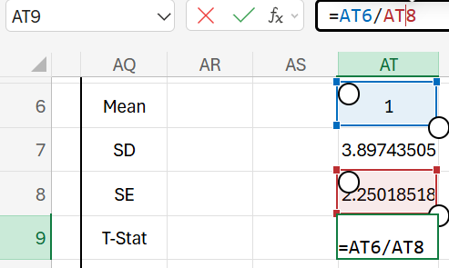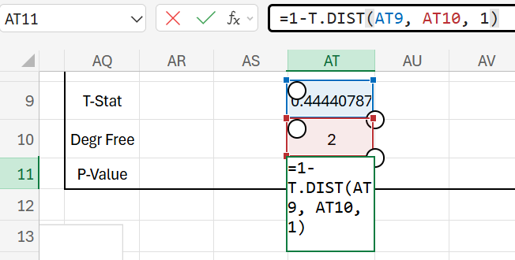

# **Instrument-specific marking guide (ISMG)**

### Criterion: Forming

|  |  |
| --- | --- |
| **The student work has the following characteristics:** | **Marks** |
| * a considered rationale for the experiment * justified modifications to the methodology * a specific and relevant research question * a methodology that enables the collection of sufficient and relevant data * appropriate use of genre and referencing conventions | 4 - 5 |
| * a reasonable rationale for the experiment * feasible modifications to the methodology * a relevant research question * a methodology that enables the collection of relevant data * use of basic genre and referencing conventions | 2 - 3 |
| * a vague or irrelevant rationale for the experiment * inappropriate modifications to the methodology * an inappropriate research question * a methodology that causes the collection of insufficient and irrelevant data * inadequate use of genre and referencing conventions. | 1 |
| * The student response does not match any of the descriptors above. | 0 |

### Criterion: Finding

|  |  |
| --- | --- |
| **The student work has the following characteristics:** | **Marks** |
| * considered management of risks/ethical issues/environmental issues * collection of sufficient and relevant raw data * fluent and concise use of scientific language and representations | 4 – 5 |
| * management of risks/ethical issues/environmental issues * collection of relevant raw data * competent use of scientific language and representations | 2 – 3 |
| * inadequate management of risks/ethical issues/environmental issues * collection of insufficient and irrelevant raw data * simplistic use of language and representations. | 1 |
| * The student response does not match any of the descriptors above. | 0 |

### Criterion: Analysing

|  |  |
| --- | --- |
| **The student work has the following characteristics:** | **Marks** |
| * + correct and relevant processing of data   + thorough identification of relevant trends/patterns/relationships   + thorough and appropriate identification of the uncertainty and limitations of evidence | 4 – 5 |
| * + basic processing of data   + identification of obvious trends/patterns/relationships   + basic identification of uncertainty and/or limitations of evidence | 2 – 3 |
| * + basic processing of data   + identification of obvious trends/patterns/relationships   + basic identification of uncertainty and/or limitations of evidence | 1 |
| * The student response does not match any of the descriptors above. | 0 |

### Criterion: Interpreting and Evaluating

|  |  |
| --- | --- |
| **The student work has the following characteristics:** | **Marks** |
| * + justified conclusion/s linked to the research question   + justified discussion of the reliability and validity of the experimental process   + suggested improvements and extensions to the experiment that are logically derived from the analysis of evidence | 4 – 5 |
| * + reasonable conclusion/s relevant to the research question   + reasonable description of the reliability and/or validity of the experimental process   + suggested improvements and/or extensions to the experiment that are related to the analysis of evidence | 2 – 3 |
| * + inappropriate or irrelevant conclusion/s   + cursory or simplistic statements about the reliability and validity of the experimental process   + ineffective or irrelevant suggestions. | 1 |
| * The student response does not match any of the descriptors above. | 0 |